STC Team Meeting (1/28)

Timestamp:
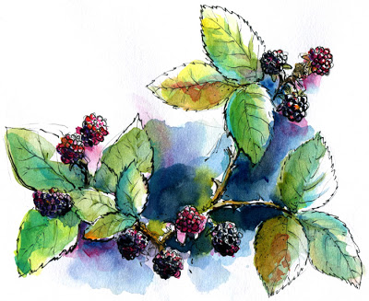
-Tuesday, Jan 28 from 11:30 - 12:30

Location:
-Library

Members Present:
-Jayleen, Piper, Bekah

Tasks:
-Project 2

Discussion Topics and Conclusion:
-Pick individual editing/re-design projects
-Project 2
-Look at UI work
-Color palette
-Logos

Proposed Topics for Next Meeting:
IN CLASS: What is the “preliminary Instructional and other Content Design Plan for the app”?

User Persona Profile Descriptions:
(Name, age, usage for app, etc.)
Piper- forager
Jayleen- Tourist and Scientists
Rebekah- Local residents

WHAT IF? Berries ripen faster so harvest seasons may be different

